**Git Module 2, Assignment 5**

**To Do :**

● Create a gitflow workflow architecture on git

● Create all the required branches

● Starting from the feature branch, push the branch to the master, following the architecture

● Push a urgent.txt on master using hotfix

**Solution :-**

//made new instance.

Mkdir asst5

Cd asst5

vi cbm.txt

git add cbm.txt

gt commit –m “added cbm.txt”

git push origin master

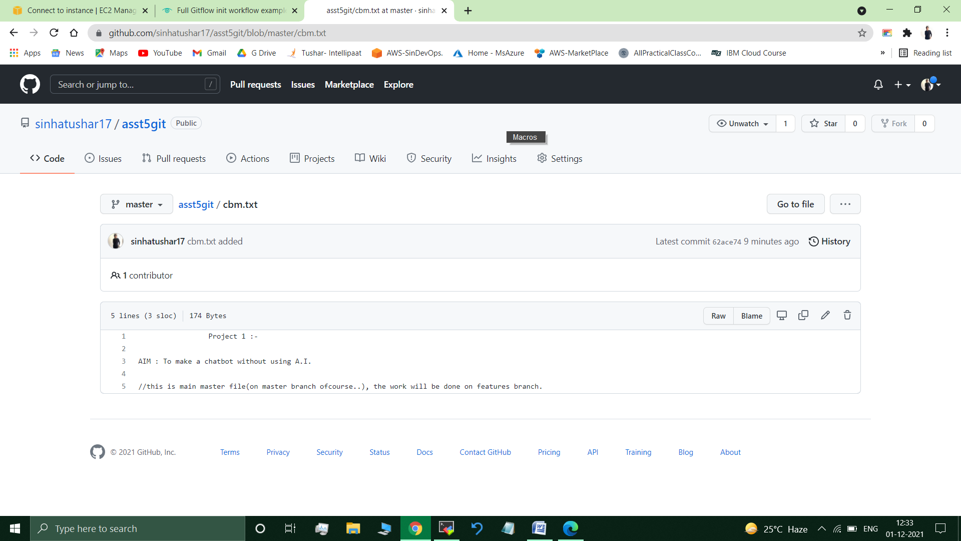

git branch develop

git branch featureA // All required branches created. **(Workflow Architecture Created)**

ls //cbm.txt present

git checkout featureA // Switched to branch 'featureA'

vi cbm.txt

cat cbm.txt

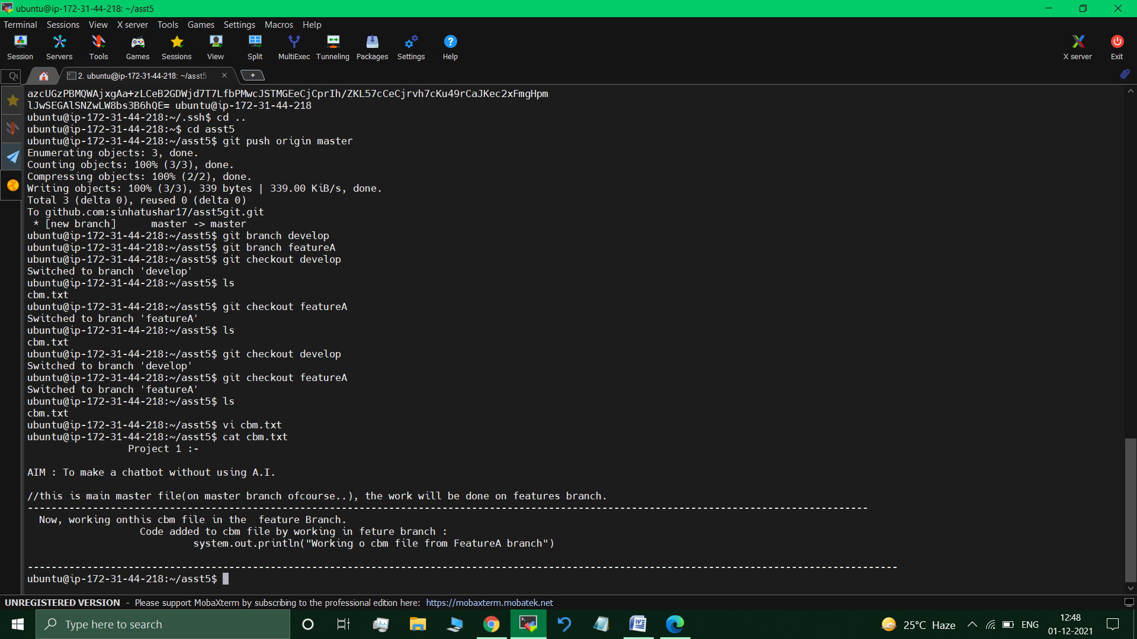

git checkout develop

git add cbm.txt

git commit -m "new changes in cbm from feature"

git push origin develop //changes from featureA pushed to develop branch

git checkout fetureA

vi cbm2.txt

cat cbm2.txt

// Continuing to work on cbm file , just adding new codes to this file, if it will be bug free then it will be added to final cbm file.

**New codes added :**

-------------------------------------------------------------

another new test code :-

system.out.println("new code(Psudo)")

git checkout develop

git add cbm2.txt

git commit -m "cbm2.txt added to develop"

git push origin develop

//cbm2.txt is not the required code/file so not pushing it to master. (it will reside in hotfix only)

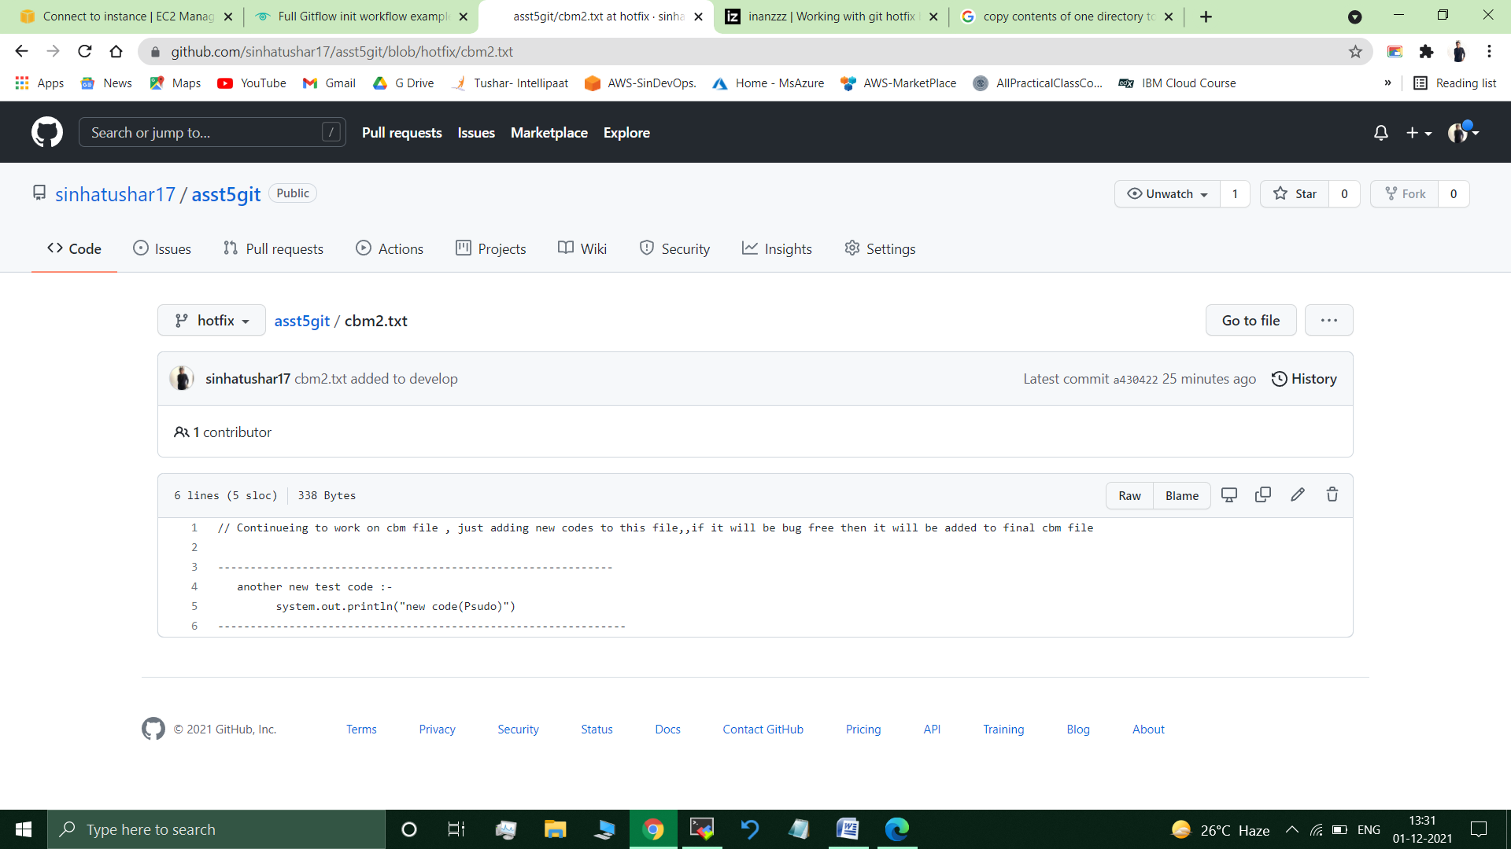

// Gitflow Workflow architecture working fine.

git branch –b hotfix

touch urgent.txt

cp cbm2.txt urgent.txt

cat urgent.txt

// Continuing to work on cbm file , just adding new codes to this file,,if it will be bug free then it will be added to final cbm file

**More new codes added :**

-------------------------------------------------------------

another new test code :-

system.out.println("new code(Psudo)")

--------------------------------------------------------------

Adding new urgent code for the new stable release :

system.out.println("New Urgent Codes");

git push origin hotfix

//now pushing this urgent.txt file from hotfix branch to master branch.

git checkout master //Switched to branch 'master'

git checkout hotfix urgent.txt //Copied urgent.txt from hotfix to master branch

Ls //cbm.txt urgent.txt //urgent.txt present on master breanch

git add urgent.txt

git commit -m "urgent.txt push to master branch"

git push origin master //urgent.txt pushed to master branch.

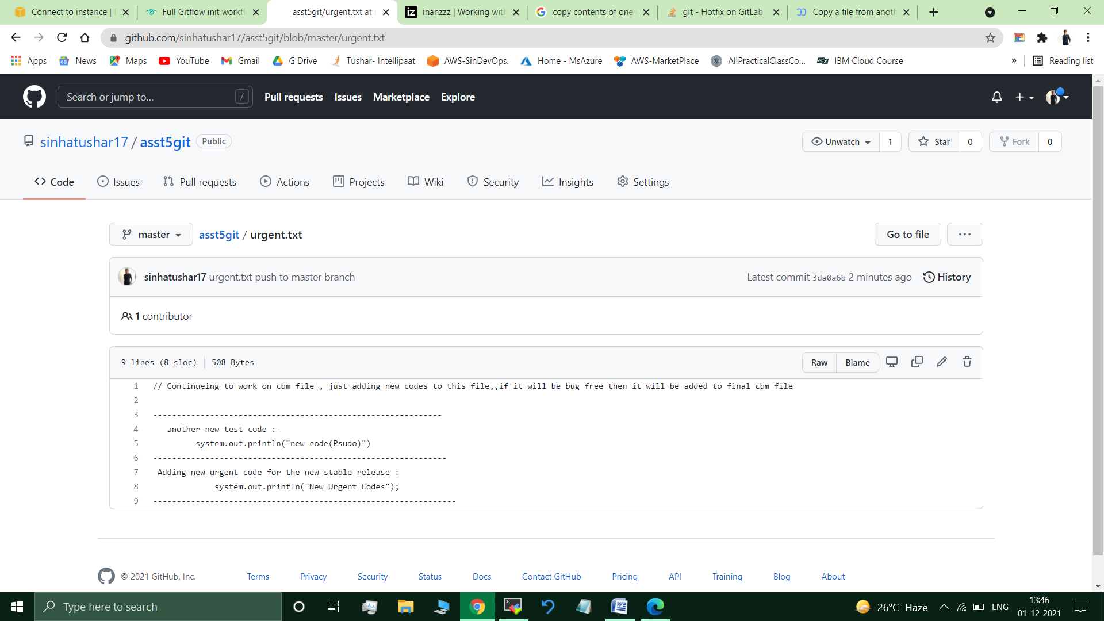

**Submitted By : Tushar Sinha**

**Email ID :** [**sinhatushar17@gmail.com**](mailto:sinhatushar17@gmail.com)

**Enrolled in the “DevOps Architect Master’s Training Program”**